CENWP-OD-B 30 August 2010

MEMORANDUM FOR THE RECORD

SUBJECT: Dead chinook at Bonneville’s Adult Fish Facility (AFF).

On 30 August at approximately 1400, CRITFC researchers were in the process of releasing fish from the brail pool. One chinook appeared to be having difficulty recovering in the brail pool prior to release. When the brail pool gate was lifted, fish thrashed around, possibly causing injury to a second chinook. CRITFC made attempts to recover the two chinook, but were unsuccessful. Both fish were in good condition during sampling. CRITFC notified Project Fisheries and collected the following information:

- Species – Chinook (2)
- Origin – clipped
- Length – 66cm and 68cm
- Marks and tags - 3D9.1C2D3F1F96 and 3D9.1C2C4A4C67
- Marks and Injuries found on the carcass – Minor pinniped marks
- Cause and Time of Death – 1400
- Future and Preventative Measures – Brail pool operations and impact scenarios will be discussed with researchers.

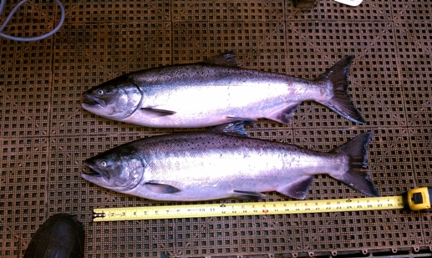

Bonneville Fisheries

